ASSINGMENT – 23

To create a table;

Create table departments(dept)id number, dept_name varchar(30));

Code:

create or replace procedure p_dept is

p_dept_id departments.dept_id%type;

p_dept_name departments.dept_name%type;

begin

p_dept_id:=8;

p_dept_name:='Computer science';

insert into departments(dept_id,dept_name)

values(p_dept_id,p_dept_name);

end;

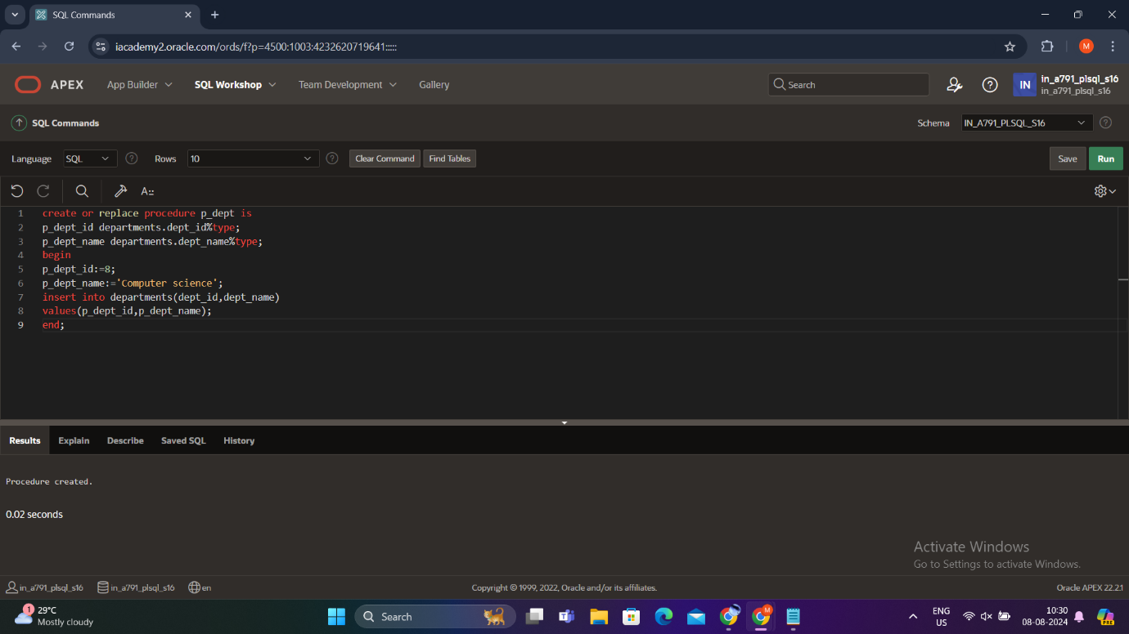

begin

p_dept;

end;

/

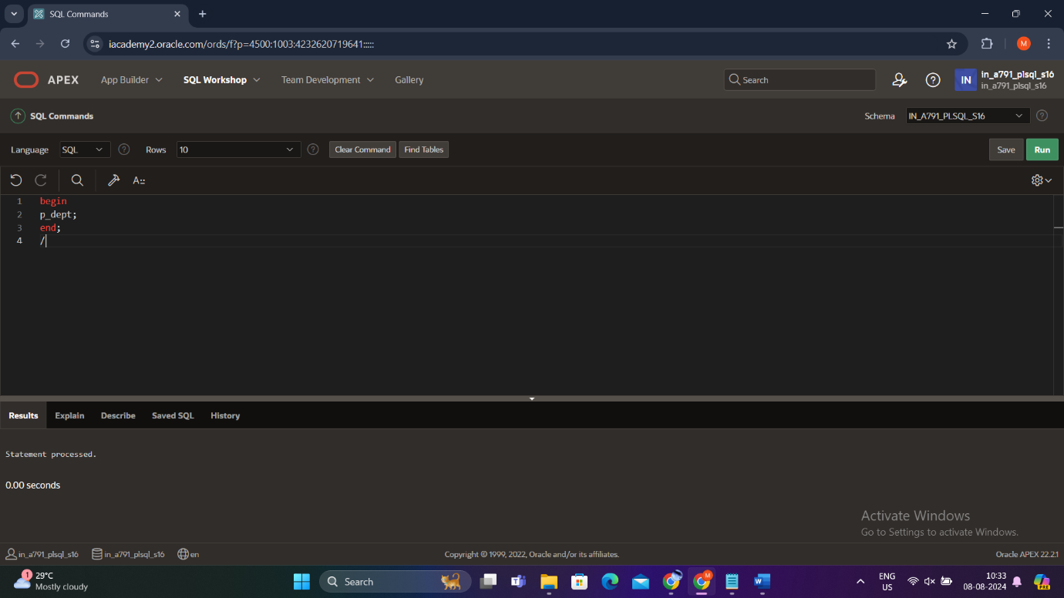

Output:

Select * from Departments;

